Information engineer in the third year , I work on programming websites. He obtained his certificate in 2023 , which is a certificate specialized in the web

**Prodesign Inc.**

**Front end Developer**

**2023**

Reading

Writing

Music

Photography

Irbin, Alnoor square

0964807067

Amjd96196@gmail.com

**EXPERIENCE**

**EDUCATION**

**HOBBIES**

**CONTACT**

**PROFILE**

**Amjad Sharaf**

CURICULUM VITAE

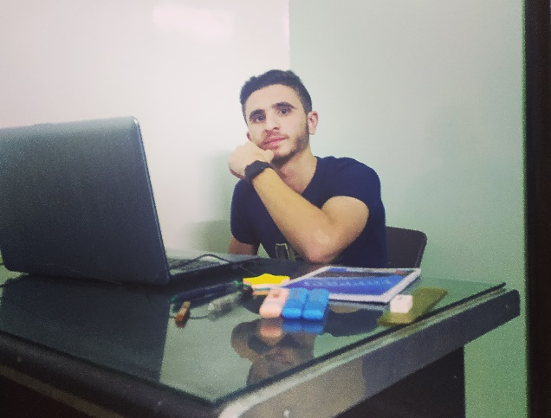

**I studied in an Institute in 2023**

**Frond end:**

**Html , css and java script**

**Back end :**

**PHP, laravel**

**UNIVERSITY OF**

**I have been Studing information technology since 2021 in a third year**

391-mail4.png

067-phone.png

001-home.png

202-sphere.png

032-book.png016-camera.png

006-pencil.png018-music.png